Project Planning Phase
Project Planning Template (Product Backlog, Sprint Planning, Stories, Story points)

Date | 29 September 2026
Team ID | SWTID-2026-5599
Project Name | Study Buddy
Maximum Marks | 5 Marks

Product Backlog, Sprint Schedule, and Estimation (4 Marks)
Use the below template to create product backlog and sprint schedule
Sprint | Functional Requirement (Epic) | User Story Number | User Story / Task | Story Points | Priority | Team Members
Sprint-1 | Registration | USN-1 | As a user, I can register for the application by entering my email, password, and confirming my password. | 2 | High | Akash, Adhithya
Sprint-1 | Login | USN-2 | As a user, I will receive confirmation email once I have registered for the application | 1 | High | Akash, Adhithya
Sprint-2 | Social Media Integration | USN-3 | As a user, I can register for the application through Facebook | 2 | Low | Malathi, Sathish
Sprint-1 | Social Media Integration | USN-4 | As a user, I can register for the application through Gmail | 2 | Medium | Akash, Sathish
Sprint-1 | Login | USN-5 | As a user, I can log into the application by entering email & password | 1 | High | Adhithya, Malathi
Sprint-2 | Dashboard | USN-6 | As a user, I can view my dashboard after login, which shows my profile, progress and quick links. | 3 | Medium | Adhithya, Malathi
Sprint-2 | Course Access | USN-7 | As a user, I can access course materials, videos and notes from the dashboard. | 3 | Medium | Akash, Sathish
Sprint-2 | Progress Tracking | USN-8 | As a user, I can track my learning progress and see completed topics. | 2 | Low | Akash, Malathi

Project Tracker, Velocity & Burndown Chart: (4 Marks)
Sprint | Total Story Points | Duration | Sprint Start Date | Sprint End Date (Planned) | Story Points Completed (as on Planned End Date) | Sprint Release Date (Actual)
Sprint-1 | 20 | 6 Days | 18 Sep 2026 | 23 Sep 2026 | 20 | 23 Sep 2026
Sprint-2 | 20 | 6 Days | 24 Sep 2026 | 29 Sep 2026 | 18 | 29 Sep 2026

Velocity:
Imagine we have a 10-day sprint duration, and the velocity of the team is 20 (points per sprint). Let’s calculate the team’s average velocity (AV) per iteration unit (story points per day)

Total completed = 18 + 20 = 38 points
Average Velocity = 38 ÷ 2 = 19 story points/sprint
Burndown Chart:
A burn down chart is a graphical representation of work left to do versus time. It is often used in agile software development methodologies such as Scrum. However, burn down charts can be applied to any project containing measurab progress over time. 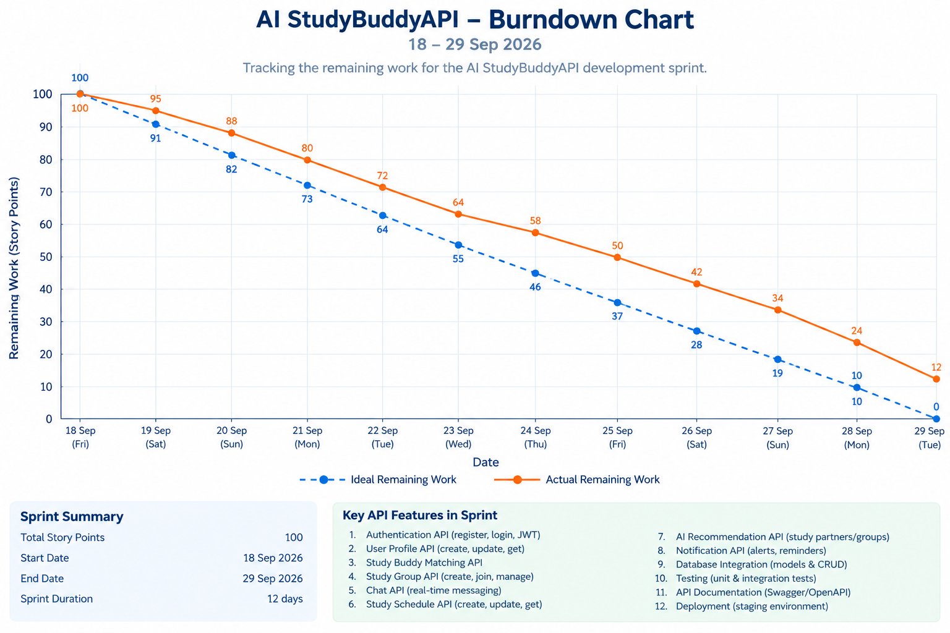le

